**Experiment No.: 1**

**Aim**

Familiarisation of linux commands.

**CO1**

Perform system administration task.

# Procedure

## 1. pwd (Print Working Directory)

To find out the path of the current working directory (folder) you’re in.

Commad:$pw

# Output Screenshot



## 2. ls

The ls command is used to view the contents of a directory. By default, this command will display the contents of your current working directory. **a. ls -R:**

ls -R will list all the files in the sub-directories as well

Command: $ls-R

# Output Screenshot

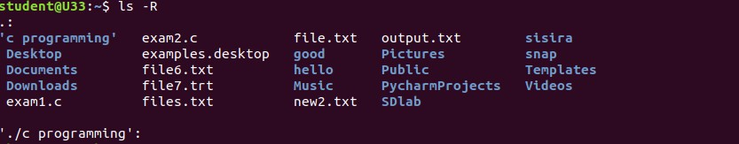

**b. ls –l:**

ls –l – long listing

Commad: $ls-l

# Output Screenshot

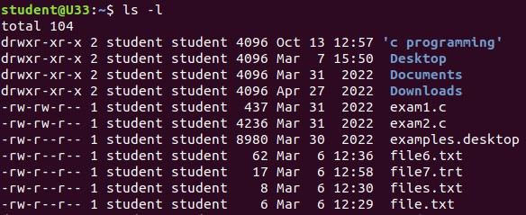

**c. ls-a:**

ls -a will show the hidden files

Commad: $ls-a

# Output Screenshot



**d. ls-al:**

ls -al will list the files and directories with detailed information like the permissions, size, owner, etc.

Command: $ls-al

# Output Screenshot

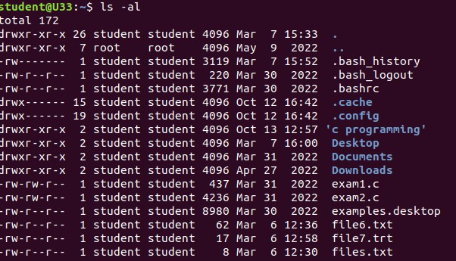

# e. ls-t

ls -t lists files sorted in the order of “last modified”

Command: $ls-t

## Output Screenshot

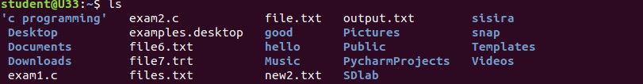

# f. ls -r

To reverse the natural Sorting order

Command: $ls -r

## Output Screenshot



### 3. history

To review the commands, you have entered before.! command number to run a command from history.

Command: $ history

## Output Screenshot

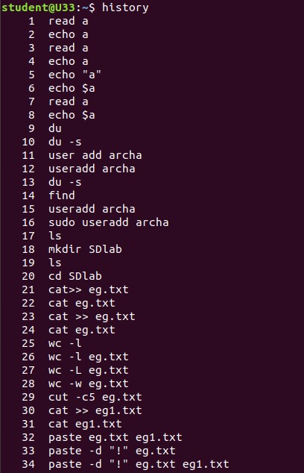

### 4. man

We can learn and understand about different command right from the shell using man command

Command: $man ls

## Output Screenshot

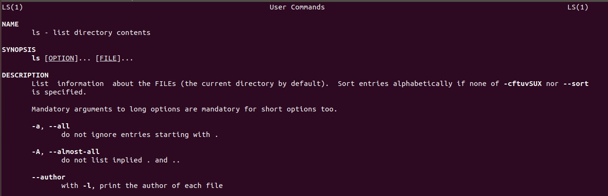

### 5. mkdir

creates new directory

Command: $mkdir sisira **Output Screenshot**



### 6. rmdir

To remove directory

Command: $rmdir sisira

## Output Screenshot

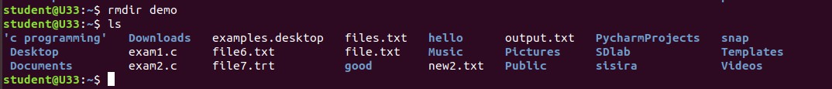

### 7. Touch

The touch command allows you to create a blank new file through the Linux command line.

Command: $touch file.txt

## Output Screenshot



**8. Cat**

It is used to list the contents of a file on the standard output. **a. Cat > file2**

Create a new file and open it to add content

Command: $cat > [filename]

## Output Screenshot

**b. cat >> [filename]**

To append new contents to existing file contents

Command:$cat >> [filename] **Output Screenshot**

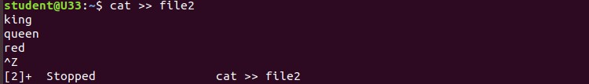

**C. cat [filename]**

To display file contents.

Command: $cat filename

## Output Screenshot

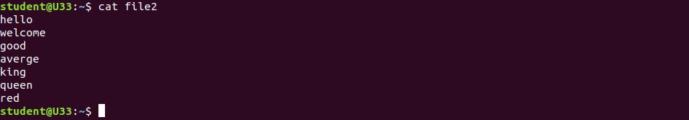

**d. cat -n [filename]:**

To display content with line numbers

Command: $cat -n filename

## Output Screenshot

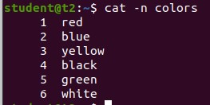

**e. cat -b [filename]:**

No line numbering for blank spacing.

Commad: $cat -b filename

## Output Screenshot

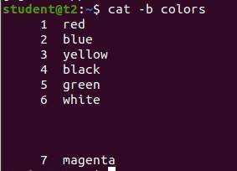

**f. cat -e [filename]:**

To display $ character at the end of each line.

Commad: $cat -e [filename]

## Output Screenshot

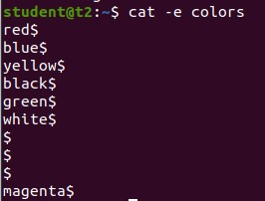

## Result

The program was executed and the result was successfully obtained. Thus CO1 was obtained.

**Experiment No.: 2**

**Aim**

Familiarisation of linux commands.

**CO1**

Perform system administration task.

**Procedure**

# 1.Cut

For Cutting out Section from each Lines of lines and writing the result to standard Output **a. Cut by byte position**

Command: $cut -b1 new1.txt

**Output Screenshot**

# b. Cut by character

Command: $cut -c1 new1.txt

**Output Screenshot**

# b. Cut by Delimiter (-, * , /, ,+………..etc)

Command: $cut -d-f1 new1.txt

**Output Screenshot**

# 2.Paste

Used to Join file horizontally each file consisting for Different lines

Command : $paste [filename] file1 > file2

**Output Screenshot**

# a. delimiter

Command : $paste -d ‘%’ file1.txt file2.txt

**Output Screenshot**

# b. $paste -s [filename]

display the content in one single line

Command: $paste -s file1.txt

**Output Screenshot**

# 3.Copy

To copy the content to a new file.

Command: $cp new3.txt new6.txt

**Output Screenshot**

# a. cp -r

Used to Copy directory allows with its sub directory

**Output Screenshot**

## Result

The program was executed and the result was successfully obtained. Thus CO1 was obtained.

**Experiment No : 3**

**AIM**

Familiarization of LINUX Commands.

**CO2**

Perform system administration task.

**Procedure**

1. read command to accept single line of input

$ read

# Output

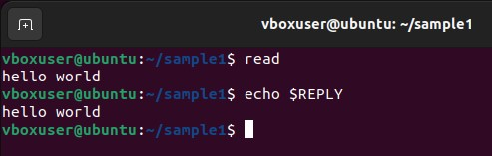

1.1) read [variable names] to read contents of a line into variables.

$ read v1 v2 v3

## Output

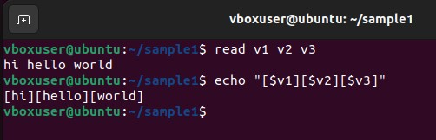

1.2) read –p [user command prompt]

to prompt user to enter values.

$ read –p “Enter your name”

## Output

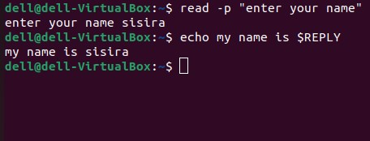

1.3) read –n [specified character limit] [user command prompt]

to prompt the user to enter values and is restricted to the character limit

specified by user.

$ read in 5 “Enter 5 characters only “

## Output

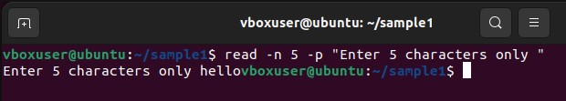

1.4) read –s –p [user command prompt]

to prompt user to enter values which is secured and invisible to the user.

$ read –s –p “Enter your password “

## Output

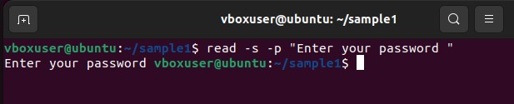

2. echo

to display the contents read by ‘$ read’ command.

$ echo $REPLY

## Output



2.1) echo [variable names]

to print the values read by ‘read’ command.

$ echo “[$v1][$v2][$v3]”

## Output



3) wc [filename]

To display number of lines, number of words, number of bytes and filename.

$wc file.txt

## Output

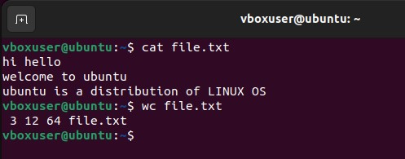

3.1) wc –l [filename]

Displays the number of lines.

$wc –l file.txt

## Output

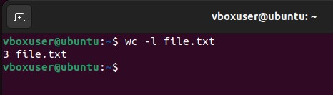

3.2) wc –m [filename]

Displays the number of characters/bytes.

$wc –m file.txt

## Output

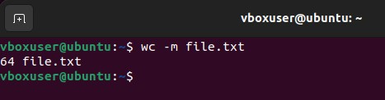

3.3) wc –w [filename]

Displays the number of words.

$wc –w file.txt

## Output

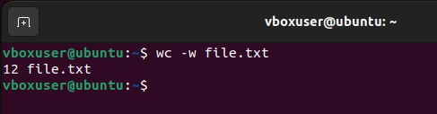

3.4) wc –L [filename]

Displays the length of longest word.

## Output

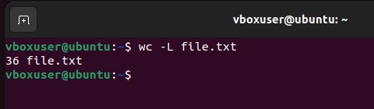

4) more [filename]

The more command is similar to cat to display the content. The only difference is that in case of large files, cat command output will scroll off your screen while more command display output one output screen at a time.

$ more samplefile.txt

## Output

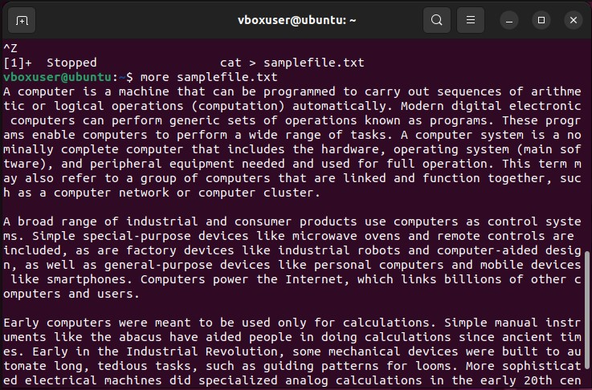

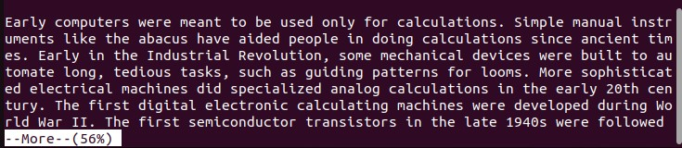

4.1) more +[specified number of lines] [filename]

To display the contents of file after specified number of lines.

$ more +5 samplefile.txt

## Output

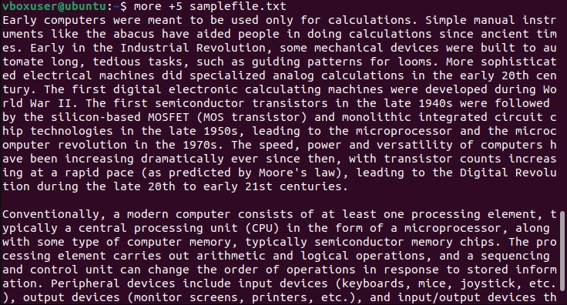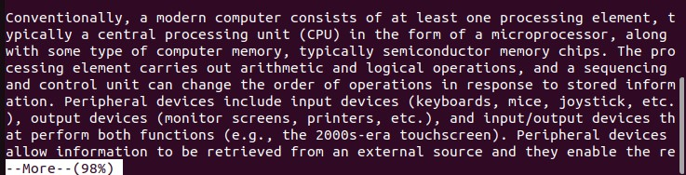

4.2) more +/[pattern] [filename]

This option is used to search the string inside your text document. You can view all the instances by navigating through the results.

$ more +/computer samplefile.txt

## Output

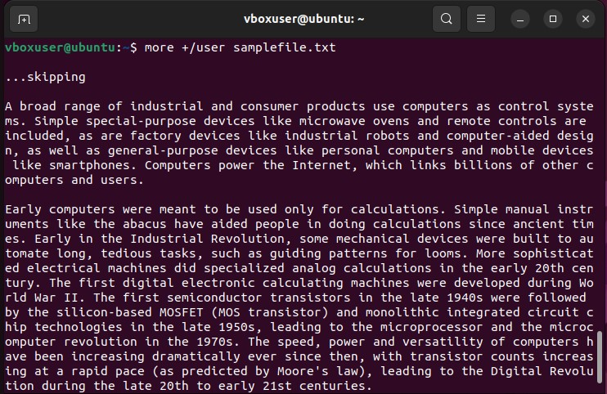

4.3) more –d [filename]

To help users to navigate through file according to the instruction. Displays “space to continue, ’q’ to quit”.

$more –d samplefile.txt

## Output

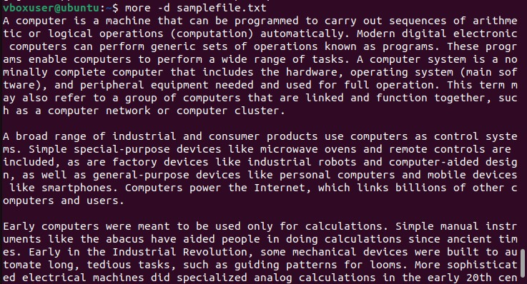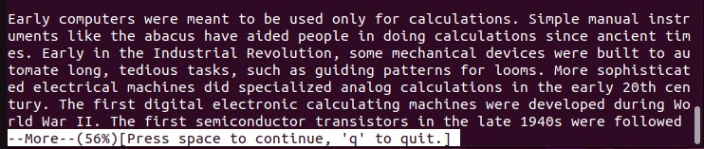

## Result

The program has been executed and output has been verified.

**Experiment No : 5**

**AIM**

Familiarization of LINUX Commands.

**CO2**

Perform system administration task.

**Procedure**

1. grep

grep command is used to filter and display contents accordingly which makes our search easy.

1.1) grep –i [pattern] [filename]

used to search the pattern and display contents accordingly, -i implies the search is insensitive.

$grep –i hindi mark

Output

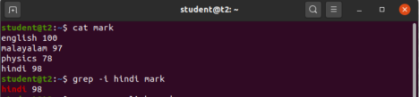

1.2) grep –v [pattern] [filename]

performs inverted search which implies displaying all the contents which does not have the specified pattern.

$ grep –v english mark

Output



1.3) grep –A1 [pattern] [filename]

displays the searched content along with a line after it.

$ grep –A1 physics mark

Output



1.4) grep –B1 [pattern] [filename]

displays the searched content along with a line before it.

$ grep –B1 physics mark

Output



1.5) grep –C1 [pattern] [filename]

displays the searched content along with a line before and after it. It works as a combination of –A1 and –B1 option of grep command.

$ grep –C1 malayalam mark

Output



2. head

displays the top contents of a file. By default, it displays first 10 lines of file. $ head number

Output



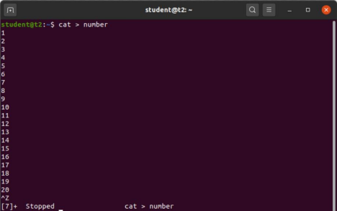

2.1) head –[number of lines] [filename]

displays only the number of lines specified by the user.

$ head -5 number

Output

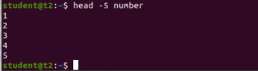

3. tail

displays the bottom contents of a file. By default, it displays last 10 lines of file. $ tail number

Output

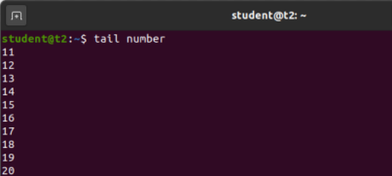

3.1) tail –[number of lines] [filename]

displays only the number of lines specified by the user.

$ tail -5 number

Output



4) mv [source file] [copy file]

To move the contents of file 1 to file 2 by overwriting the contents of file and replacing it with new name.

$ mv number number1

Output

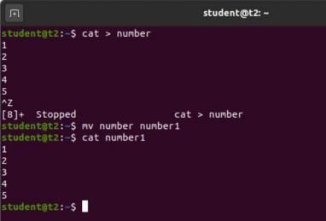

4.1) mv –b [source file] [copy file]

To move the contents of file 1 to file 2 while keeping a backup of original file. $ mv –b hello hi

Output 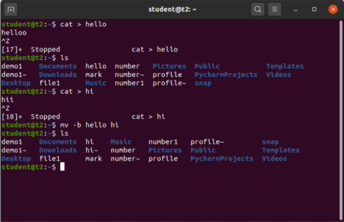

4.2) mv –i [source file] [copy file]

To move the contents of file 1 to file 2 by overwriting the original file.

$ mv –i hello hi

Output

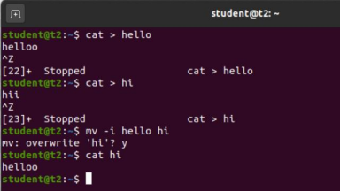Result

The program has been executed and output has been verified.

**Experiment No : 6**

**AIM**

Familiarization of LINUX Commands.

**CO2**

Perform system administration task.

**Procedure**

1. expr

evaluates the given expression and displays the output.

$ expr 12 + 8

# Output

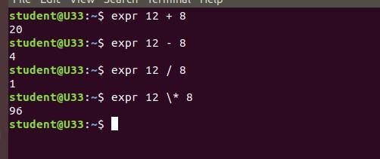

1.1) expr [$ variable1] [$ variable2]

evaluates the expression and returns value.

$ expr $x + $y

# Output

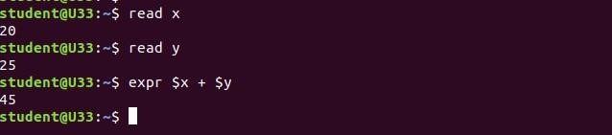

2) df

Shows the disk utilization of our system in terms of used space, megabits etc.

$ df

# Output

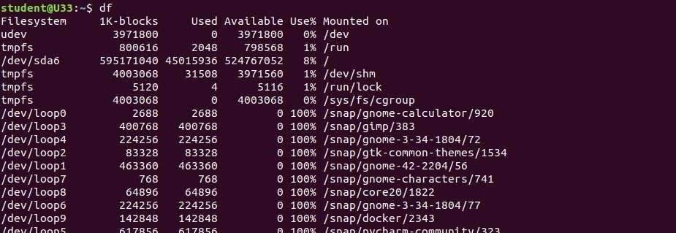

3) du [filename]

Shows the disk utilization of a specific file

$ du

# Output



1. sudo

To add new user to the system

4.1) sudo useradd [username]

Adds a user to the Ubuntu system specified by the user.

$ sudo useradd nithasha

# Output



4.2) sudo passwd [username]

To update the password of new user

$ sudo passwd sisira

# Output

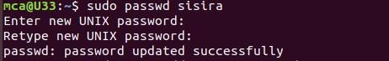

4.3) sudo groupadd –g [gid] [group name]

To create a group with a unique identifier. User would be notified if it already exists.

$ sudo groupadd –g 765 mcacommunity

# Output



4.4) sudo usermod –G [group name] [member user]

To add any existing user to the group created.

$ sudo usermod –G mcacommunity sisira

# Output



5) id [username]

Displays the group name and group id to which the user belongs to.

$ id sisira

# Output





6) compgen –g

Displays all the groups

# Output

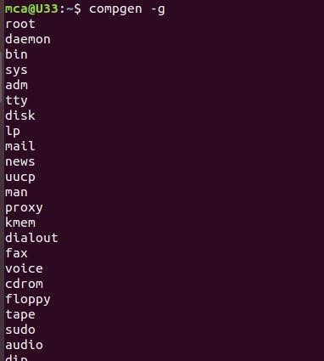

1. chmod

Used to change the access permissions of files and directories. It stands for change mod( read ( r ), write ( w ), execute ( x )..etc ).

7.1) chmod –wx [filename]

This command denies permission to write or append to the file. $ chmod –wx file

# Output

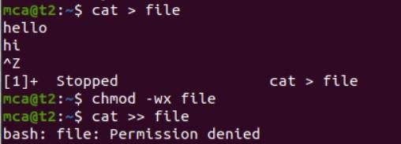

7.2) chmod +wx [filename]

This command allows permission to write or append to the file.

$ chmod +wx file

# Output

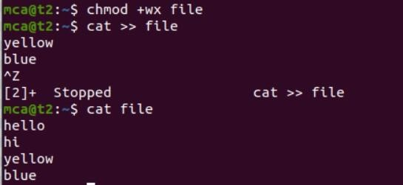

8) chown

Command used to change a file ownership or directory ownership for a user or a group. chown stands for change owner. 8.1) sudo chown [username] [filename]

Changes the file ownership from the current user to another.

$ sudo chown sisira file

# Output



Result

The program has been executed and output has been verified.

**Experiment No.: 8**

**AIM**: Familiarization of linux commands.

**CO2**: Perform system administration task.

1. Ip addr :

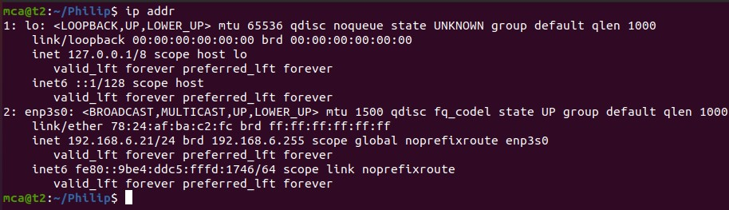

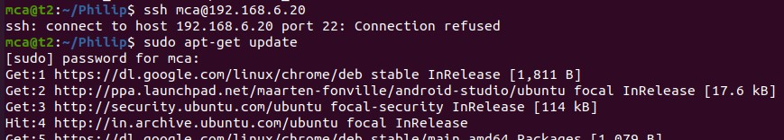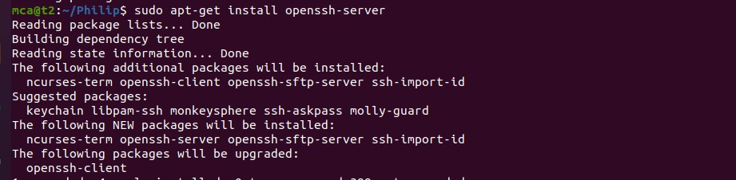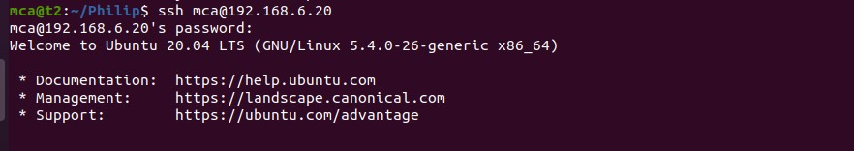

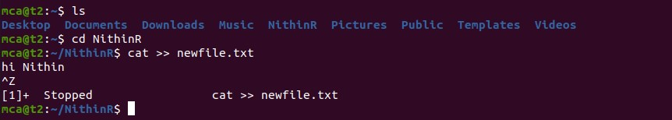

Ssh stands for secure shell

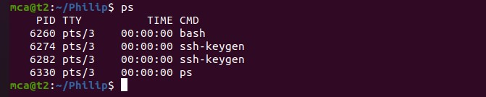Ssh-keygen : generate a key for ssh

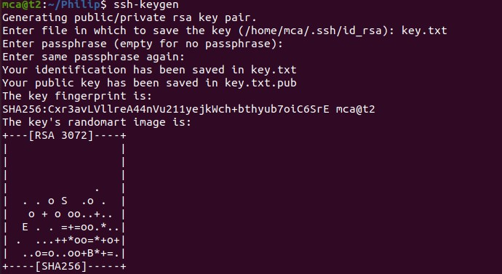

Ps : currently running program

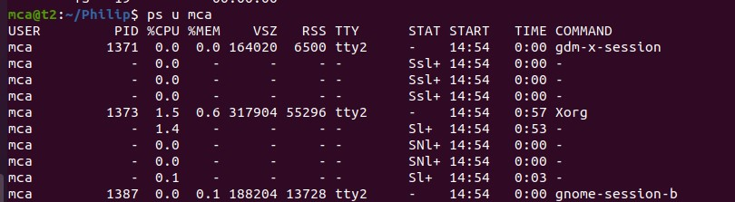

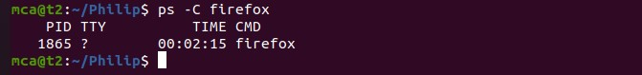

**Result**

The program was executed and the result was successfully obtained. Thus CO2 was obtained

**Experiment No.: 9**

**Aim: Network  commands.**

**CO2: Perform System Administration Tasks.**

**Procedure**

1. ifconfig : fconfig command, it provides information about the network interfaces on your system, including their IP addresses, MAC addresses, network masks, and other relevant details.

**Output Screenshot**

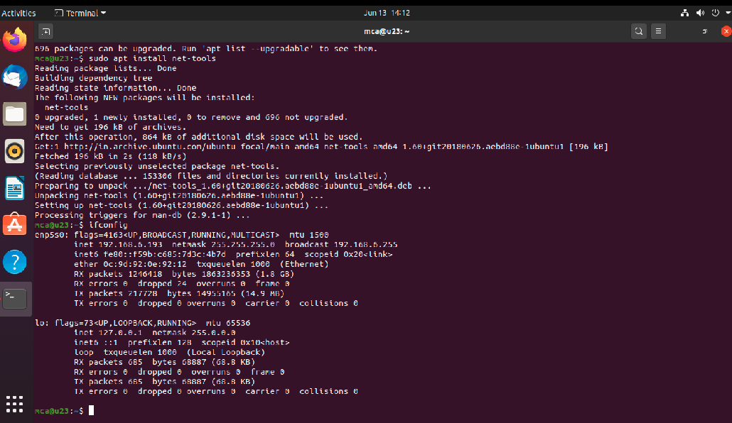

1. ping google.com : When you execute the ping command followed by a specific host or IP address, your computer sends ICMP (Internet Control Message Protocol) echo request packets to that destination. The ping utility is commonly used to troubleshoot network connectivity issues, determine network latency, and assess the overall health and responsiveness of a network.

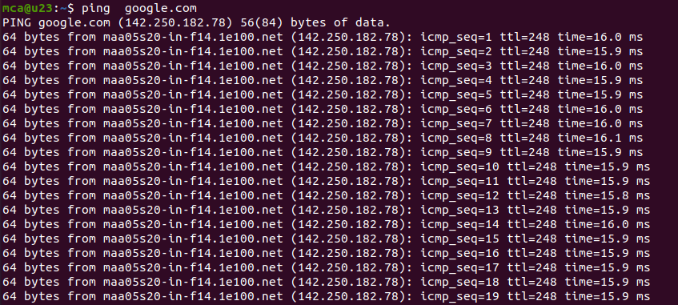

ping -c 5 google.com   When you execute ping -c 5, it sends a total of 5 ICMP echo request packets to the specified host or IP address. Once the 5 packets are sent, ping will stop automatically and provide you with a summary of the results, including statistics such as packet loss, round-trip time (RTT), and other relevant information

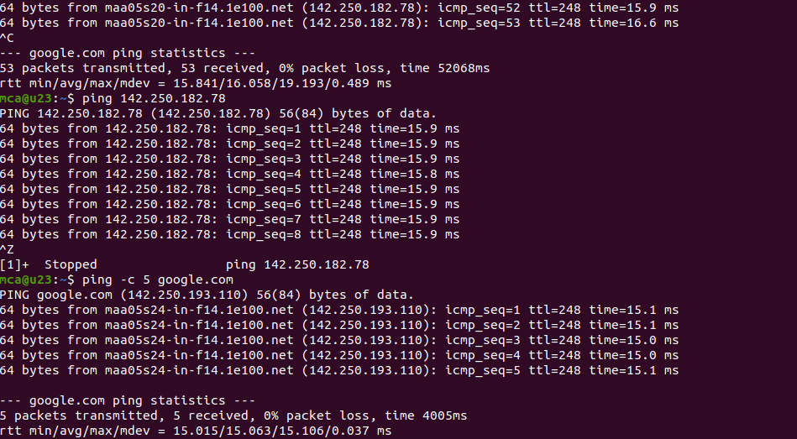

1. treceroute google.com  traceroute is a command-line network diagnostic tool used to trace the route that packets take from your computer to a destination host or IP address. It helps identify the path and measure the network latency between your computer and the destination.

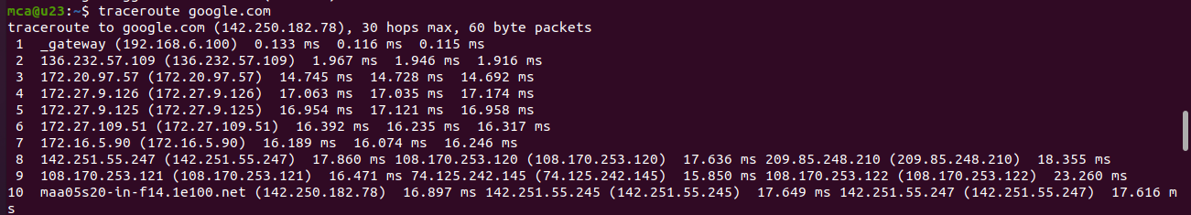

1. whois google.com   whois is a command-line utility and protocol used to retrieve information about registered domain names or IP addresses. It allows you to query a WHOIS database to obtain details about the ownership, registration, and administrative contacts associated with a particular domain name or IP address.

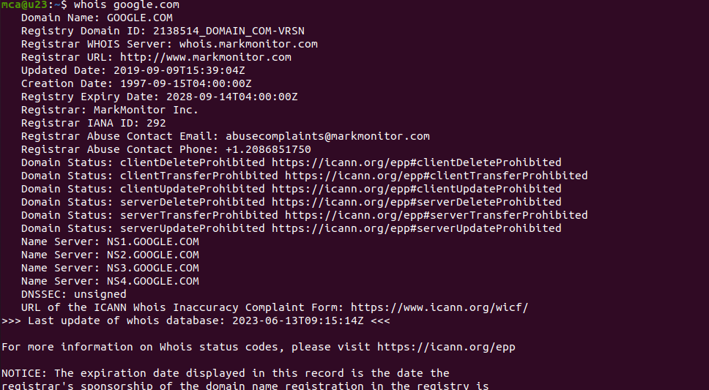

1. ifcongig enp5s0 down/up : ifconfig enp5s0 down: This command disables or "brings down" the network interface named "enp5s0".  ifconfig enp5s0 up: This command enables or "brings up" the network interface named "enp5s0".

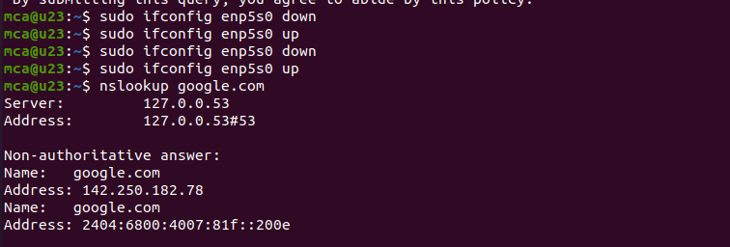

7. tcpdump :  When you run the tcpdump command, it starts capturing network packets on a specified network interface or on all interfaces if none is specified

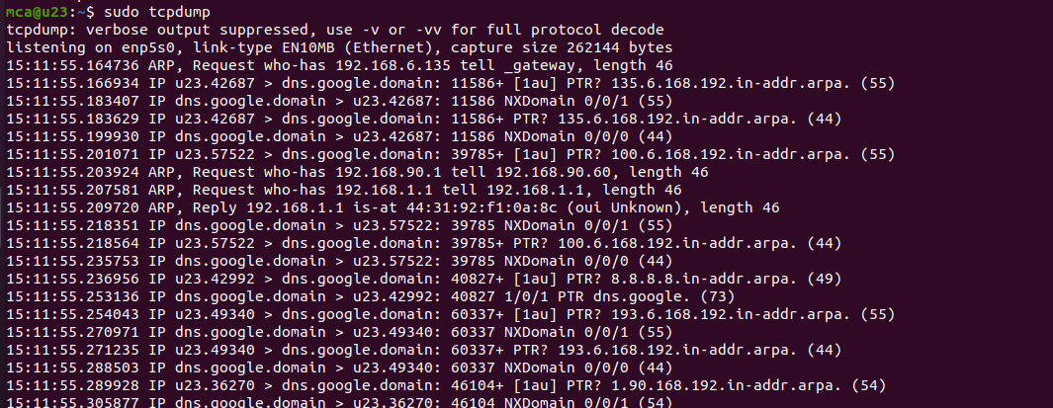

8. tcpdump -D  :  When you execute tcpdump -D, it displays a numbered list of the network interfaces detected by tcpdump on your system.

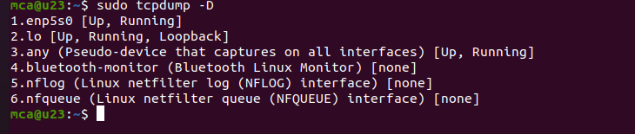

9. tcpdump -i enp5s0 :  The command tcpdump -i enp5s0 is used to capture network packets on a specific network interface, in this case, "enp5s0". When you execute this command, tcpdump will start capturing packets flowing through the specified interface.

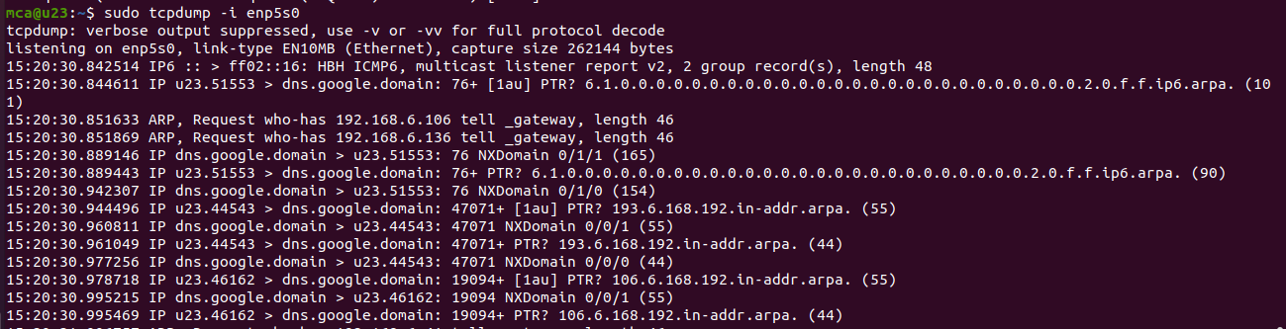

10. tcpdump -A -i enp5s0 :  The command tcpdump -A -i enp5s0 is similar to the previous command, but with an additional flag -A. This flag tells tcpdump to display the packet contents or payload in ASCII format.

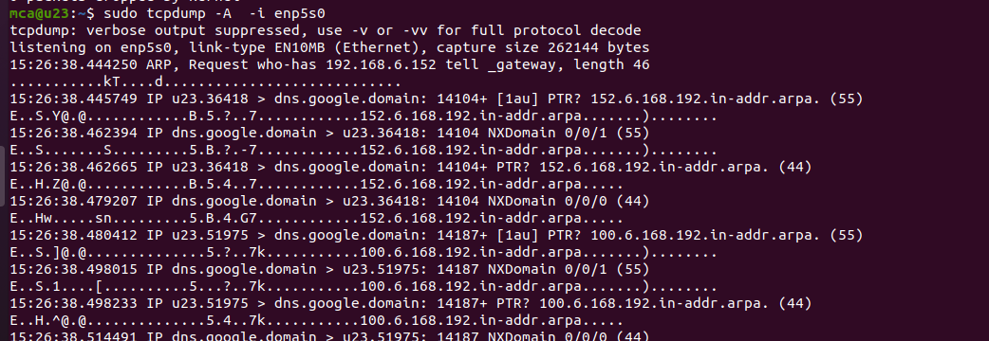

11.   tcpdump -xx -i enp5s0 :  The command tcpdump -xx -i enp5s0 is another variation of the tcpdump command with additional flags -xx. These flags modify the output format of tcpdump to display the packet contents in both hexadecimal and ASCII formats.

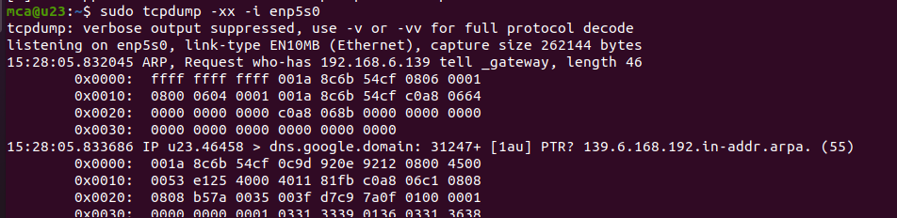

12. tcpdump -w file.txt -i enp5s0  : The command tcpdump -w file.txt -i enp5s0 is used to capture network packets on the specified network interface (enp5s0) and save the captured packets to a file named file.txt.

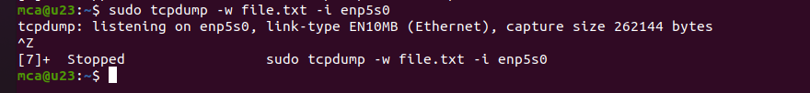

wireshark :   Wireshark is a popular and powerful network protocol analyzer. It provides a graphical user interface (GUI) that allows you to capture, analyze, and inspect network packets in real-time. Wireshark is available for multiple platforms, including Windows, macOS, and Linux.

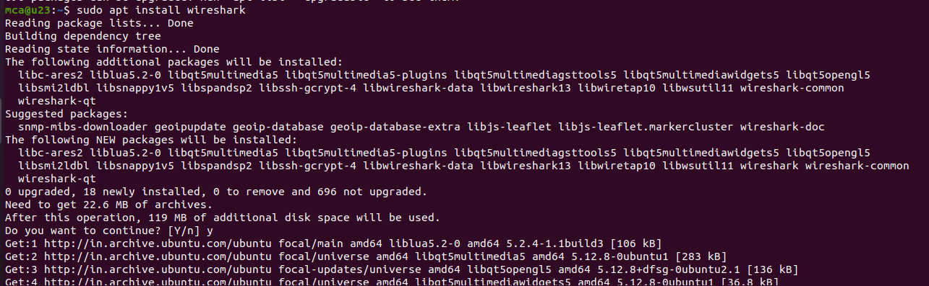



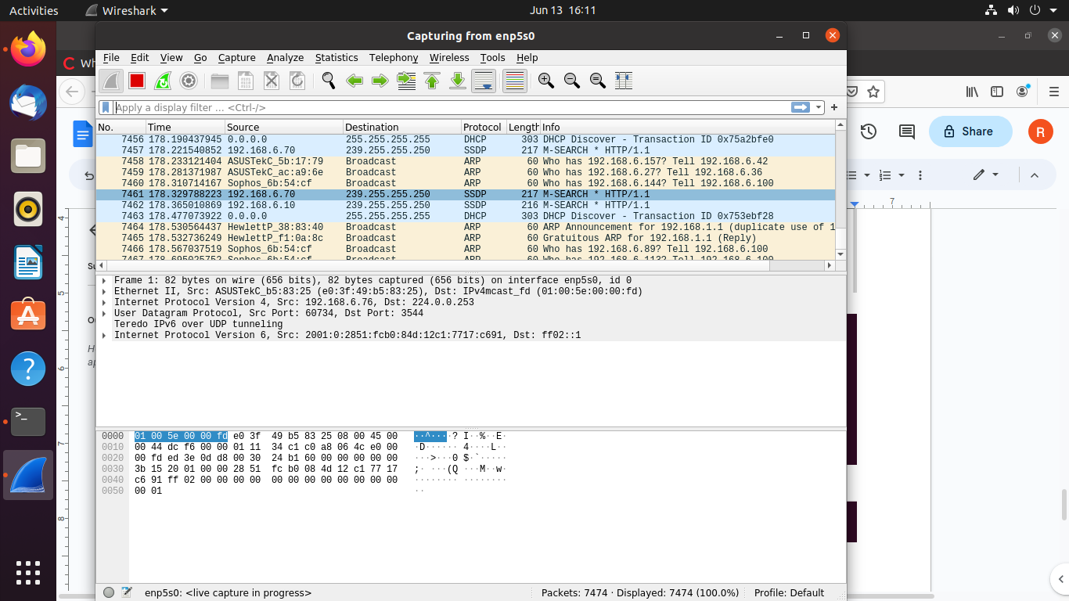

**RESULT**

The program was executed and the result was successfully obtained. Thus CO2 was obtained

**SHELL SCRIPTING IN LINUX OPERATING SYSTEM**

**EXAMPLE 1 : SHELL SCRIPT TO DISPLAY CURRENT DATE**

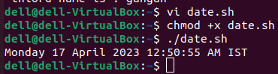

**EXAMPLE 2 : SHELL SCRIPT TO DISPLAY YOUR NAME**

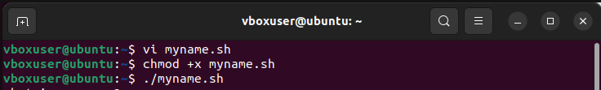

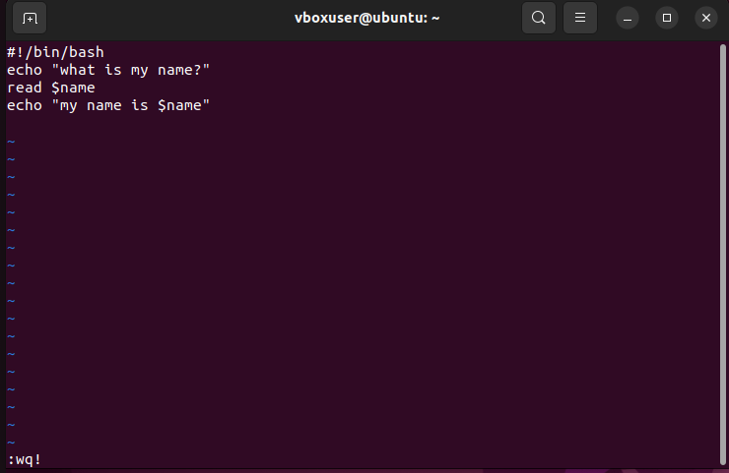

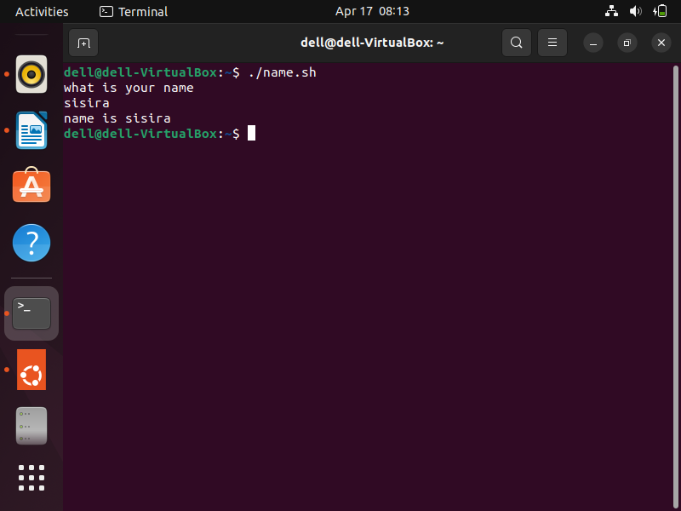

**EXAMPLE 3 : SHELL SCRIPT TO DEMOSTRATE VARIABLE**

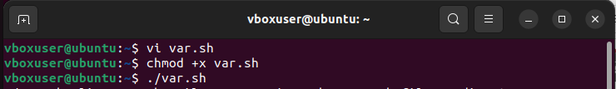

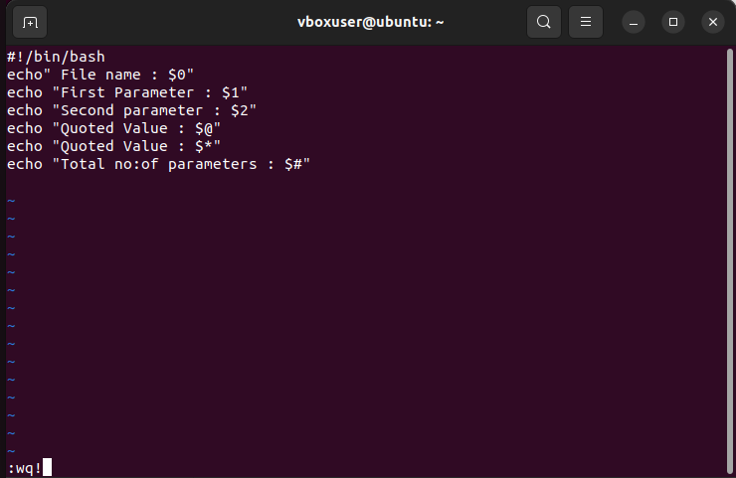

**EXAMPLE 4 : SHELL SCRIPT TO COUNT NO:OF LINES**

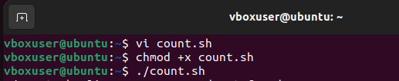

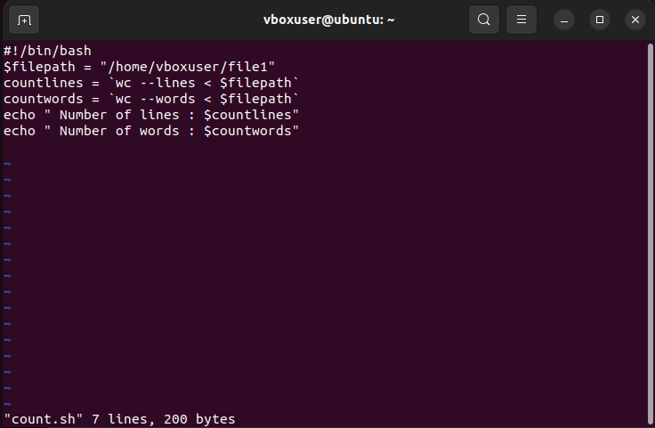

**EXAMPLE 5 : SHELL SCRIPT TO DISPLAY AN ARRAY**

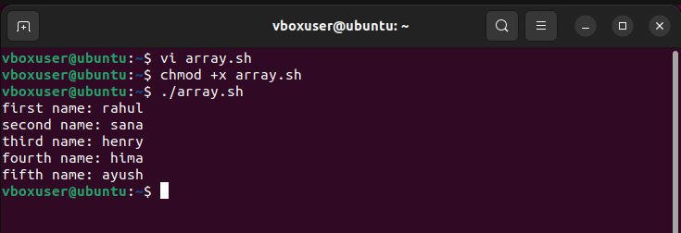

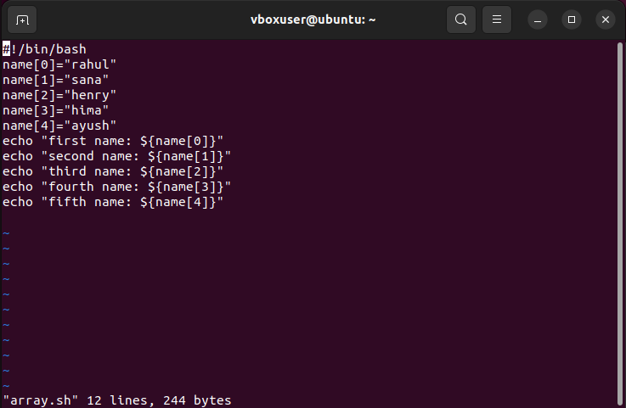

**EXAMPLE 6 : SHELL SCRIPT TO ADD 2 NUMBERS**

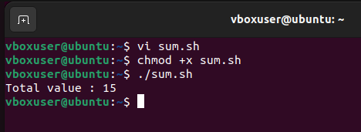

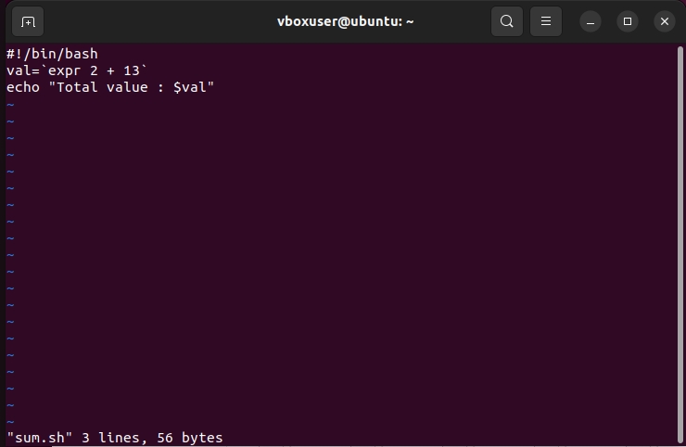

**Write an example shell script to initialize 2 numeric variables. Then perform an addition operation on both values and store result in third variable.**

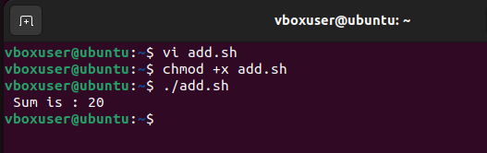

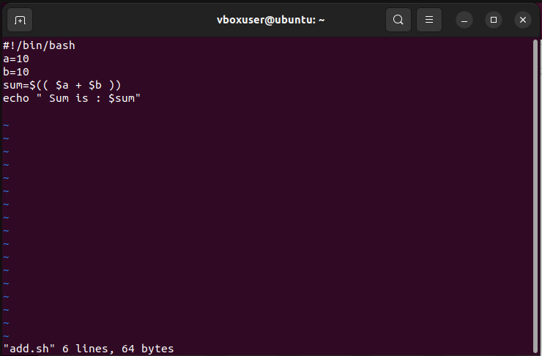

**Shell script to read 2 numbers as command line parameters and perform the addition operation.**

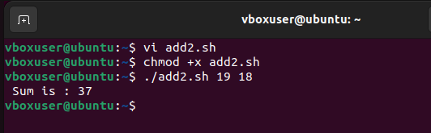

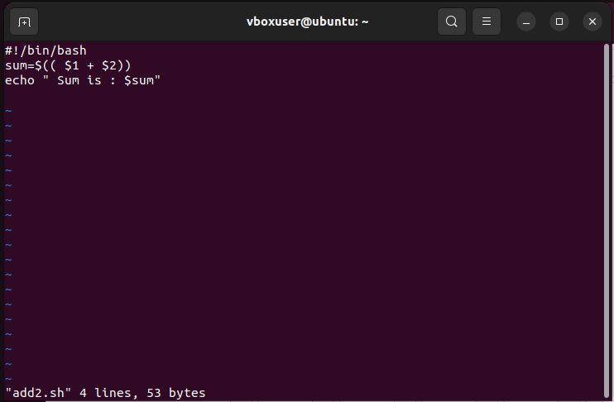

**Shell script that input from user at runtime. Then calculate sum of given numbers and calculator.**

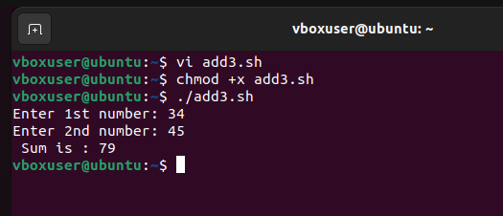

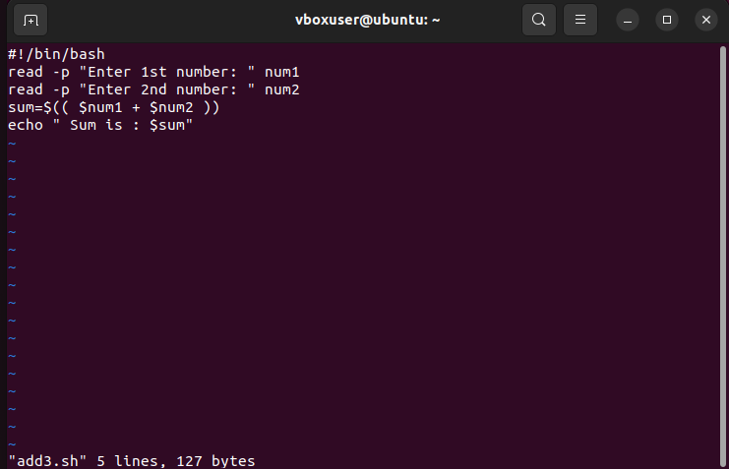

**ARITHMETIC OPERATORS**

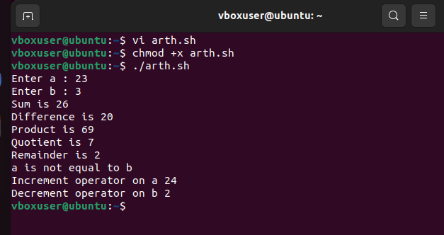

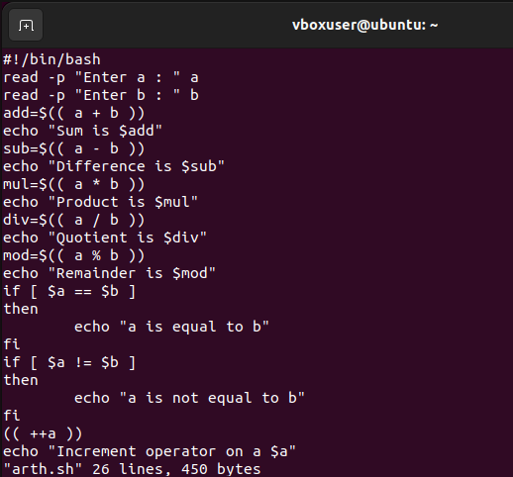

**RELATIONAL OPERATORS**

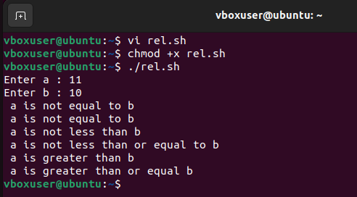

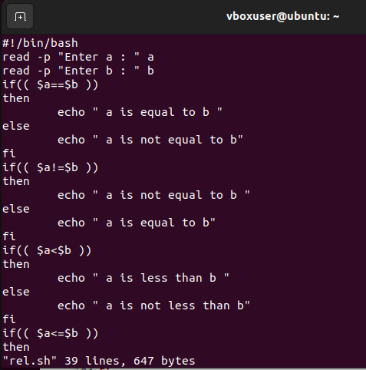

**Shell script to check whether the number is odd or even**

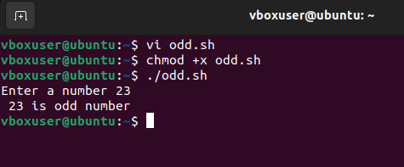

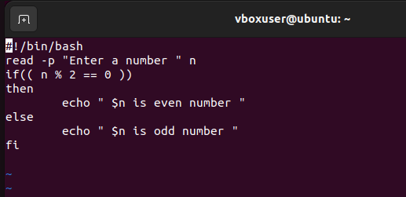

**Shell script to check whether a number is positive or negative**

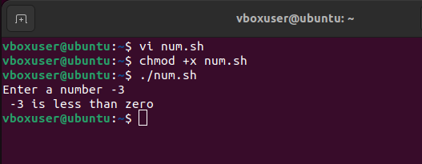

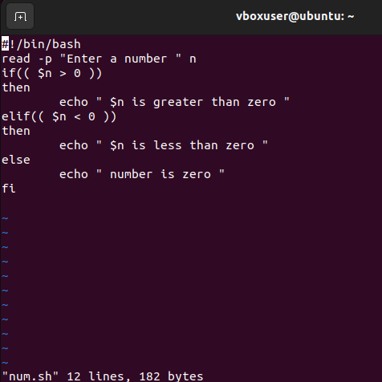

**Shell script to check which among the 2 numbers is largest.**

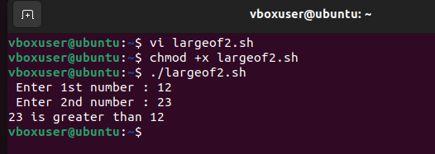

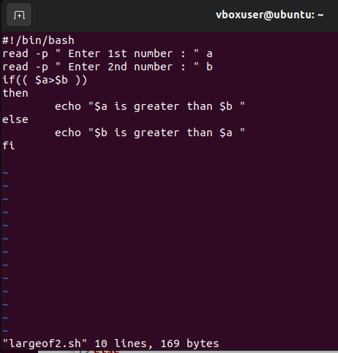

**Shell script to check which among the 3 numbers is largest.**

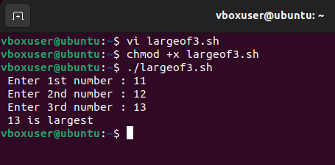

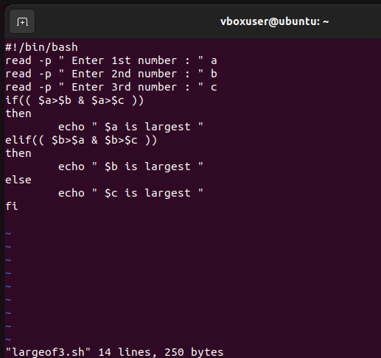

**Experiment No.: 26**

**Aim: make and cmake**

**Function1.cpp**

#include "functions.h"

int factorial(int n)

{

if(n!=1)

{

return(n*factorial(n-1));

}

else return 1;

}

**Function2.cpp**

#include <iostream>

#include "functions.h"

void print_hello()

{

std::cout << 'Hello World';

}

**Function.h**

void print_hello();

int factorial(int n);

**main.cpp**

#include<iostream>

#include "functions.h"

int main()

print_hello();

std::cout << std::endl;

std::cout << 'the factorial of 5 is' <<factorial(5)<<std::endl;

return 0;

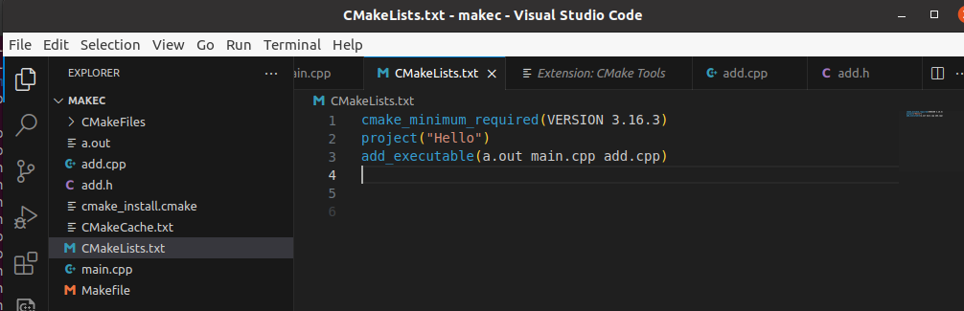

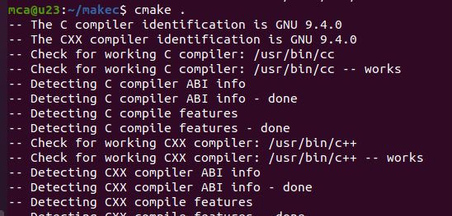

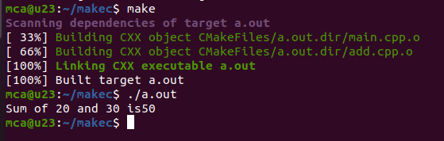

**Experiment No.:**

**Aim: File System Hierarchy**

**CO**

**Procedure**

**sudo apt update**

**sudo apt install tree**

**tree**

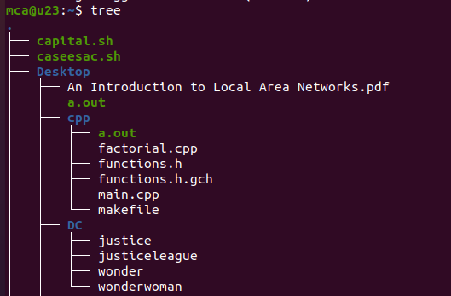

**#scrutanise each directory**

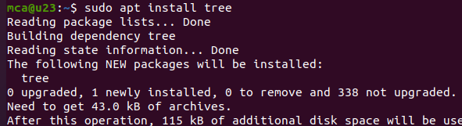

**tree /bin**

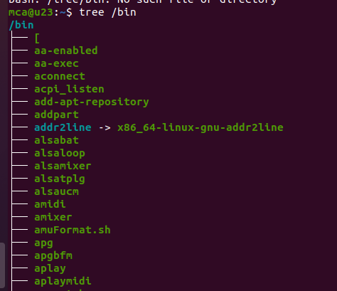

**tree /boot**

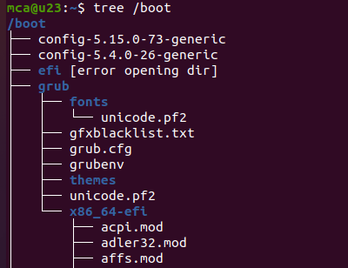

**Directories Explanation**

**/root ->** Contains all other directories and files

**/bin ->** Essential binary files which are accessible to all users.This files are prepared for basic functioning and for various system operations & user interactions.

**/boot** -> Files prepared for boot process.(including kernel,boot loader & initial ramdisk)

We want to load the os & prepare the system for use. All the files supporting the booting are stored here.

**/dev ->** Device files representing the physical & virtual devices. Such as hardwares,printers,cpu etc.

**/etc ->** The system config.files for various applications & services .Config files determines the behaviour,functionality and appearance of the system.

**/home ->** Directory for regular users.

**/mnt ->** Temporary mounted files .Temporarly attaching file system for eg: external devices,network shares .

**/media ->** Temporary mounted syste, for removable media

eg: usb,optical disk or ext hard drives.

**/sys ->** Expose information about system hardware and devices .

**/temp ->** Temp.files created by users and applications

**/usr ->** User programs and libraries

**/var ->** The variable data that changes frequently such as log & cache files.